Introduction

* Changed reference to Final Rule (versus “proposed rule”)
* Added footnote about not binding / do not have force and effect of law
* Now allowing standards to apply to rate ranges
* Made a note that adhering to standards will help CMS’ review
* More language about ensuring compliance with 42 CFR 438.4 and 7

Section I – General Information

* Added modeling ASOP and 42 CFR 438.5
* Removal of language around time periods other than 12 months
* Rate ranges allowed
  + Must clearly state
  + Added section on conditions for certifying a rate range
  + Modifications are allowed if changes <1% (for non-rate ranges this is still 1.5%), must recertify otherwise, guidance on recertifications
  + Additional documentation requirements including:
    - Assumption variations between upper/lower
    - Table showing upper does not exceed lower by 5%
    - Criteria for paying different points, including footnote of examples
    - etc
* De minimus requirement for retroactive adjustments, reconciliations
  + Retroactive rate adjustments can be submitted a either a rate amendment or new rate certification
* Added clarifying language on varying rates based on FFP
  + More documentation requirements on this later on
    - Must document all assumptions/methods that vary by rate of FFP, justify, and show financial impact
* Removed footnote about 2019 bulletin on MLR requirement related to third-party vendors
* Added section on COVID, expects states and actuaries to evaluate state, regional, national COVID data in determining how to address COVID for rate setting
  + CMS recommending 2 sided risk mitigation strategy for all PHE impacted periods
* Bunch of footnotes added about rate amendments
  + Must submit contract amendments regardless of the rate adjustment
  + Also clarification on approved risk adjustment methodology not requiring rate amendment
* Clarification on “previous rates” to compare to
* Required documentation of COVID approach

Section I – Data

* Nothing material, minor wording changes
  + Change references from “health plans” to “managed care plans”

Section I – Projected Benefit Costs and Trends

* Nothing material, minor wording changes

Section I – Special Contract Provisions Related to Payment

* Footnote about additional guidance other than this document
* Risk sharing mechanisms must be documented in rate cert prior to start of rating period, cannot be added after
* Changed Delivery System and Provider Payment Initiatives to State Directed Payments
* Clarifying language about minimum fee schedule using state plan approved rates as well as rates other than state plan approved rates
* Rate certifications including state directed payments cant be approved until all written prior approval obtained
* Method of incorporating state directed payment into rate cert will be identified as part of preprint review
* In addition to description of the arrangements must now provide this table

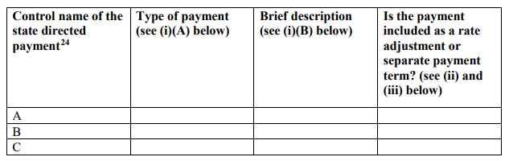

* If incorporated in base cap rates as a rate adjustment must include this table

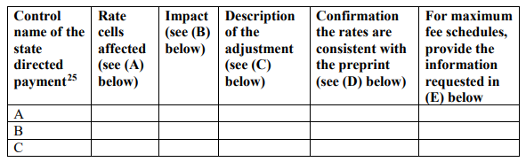

* Clearly defined references exhibits showing impact
* Cannot combine directed payments in the exhibits
* If preprint is not submitted prior to rate certification, must include specific timeline for submission
* Table for directed payments incorporated as separate payment terms

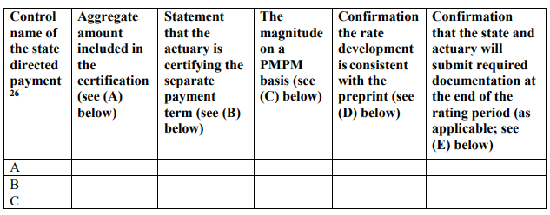

* Clarification on how to show amounts for separate payment terms
* Note this (documentation after rating period is over) is only applicable to separate payment terms that are included in the certification as separate pools that are certified in addition to the base PMPM capitation rates.
* Pass throughs
  + New footnote about transition periods: Pass-through payments to network providers that are hospitals, nursing facilities, or physicians are allowable for the transition period identified in 42 C.F.R. § 438.6(d)(6) for states transitioning services and populations from a FFS delivery system to a managed care delivery system when the state meets the requirements in 42 C.F.R. 438.6(d)(6).
  + And this section
    - In accordance with 42 C.F.R. § 438.6(d)(6), for states transitioning services or populations from a FFS delivery system to a managed care delivery system, the aggregate amount of the pass-through payments the State requires the MCO, PIHP or PAHP to make to hospitals, nursing facilities or physicians is less than or equal to the amounts calculated in 42 C.F.R. § 438.6(d)(iii)(A), (B), or (C).31
      * (A)In determining the amount of each component for the calculations contained in 42 C.F.R. § 438.6(e)(iii)(A) through (C), the State must use the amounts paid for services during the 12-month period immediately 2 years prior to the first rating period of the transition period.
  + Specific Documentation requirements for financing mechanism
  + More documentation/confirmation requirements for states transitioning services or populations from managed care to FFS
  + Explanation of changes to methodology for calculating base amount including fiscal impact

Section I – Non-Benefit Costs

* HIF sections/references removed as well as assumption variation based on FFP (may be covered by the new footnote)

Section I – Risk Adjustment and Acuity Adjustments

* Removal of note about acuity adjustments as risk mitigation strategy

Section II

* Note that all previously mentioned standards apply here as well
* Nothing else

Section III

* Note that all previously mentioned standards apply here as well
* Removal of note about assumption variation based on FFP
* Another reminder about Risk sharing mechanisms must be documented in rate cert prior to start of rating period, cannot be added after

Appendix A

* Changed language from “accelerated rate review process” to “procedures for accelerated rate review”
* Additional condition for accelerated review – must not have changed from rates to rate ranges
  + Guess this means anyone that certifies rate ranges this year cant have an accelerated review
* Included DMCO email address for submissions
* Some clarifying language
* Changes to non benefit expense table (added last two columns)

